WT-OTE-1315G 1000Mbps Media Converter
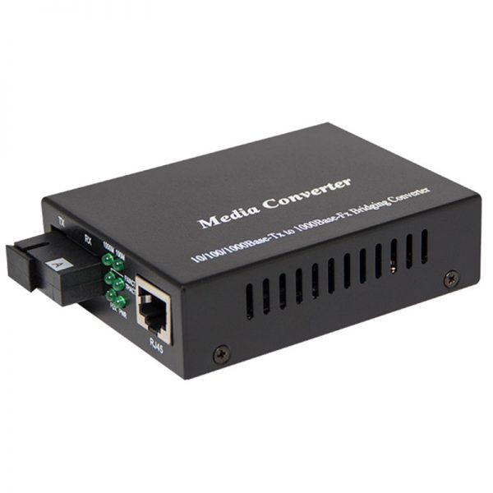
Overview
ATOFE850 the Gigabit Ethernet media converter fully complies with IEEE802.3 and IEEE802.3z standards. The twisted pair and the fiber-optic both transfer data at the rate of 1000Mbps. With single-mode fiber-optic the transmitting distance could be 10, 20, 40 and 80Km. They are applicable to city backbone network Equipments confirmed to Ethernet protocol such as Switches and Routers could all be interconnected.
Features
Fully comply with IEEE802.3 10 Base-T, IEEE802.3u 100Base Tx,IEEE802.3ab 1000Base-Tx, IEEE802.3z 1000 Base Fx standard.
WDM technology applied, Simplex fiber transfer
Compatible with Cisco,Huwei,3COMs GBIC and SFP
Auto-negotiation of 10/100/1000M bps rate and Auto-MDI/MDIX for Tx port
With 100M,1000M,PWR,Tx,Rx,FXL, LED indicators on the front panel
Easy-to-view LED indicators provides status to easily monitor network activity
Surface Mount Technology
Excellent optoelectronic module and multilayer circuit ensure data transmission stability, long working lifetime

Specification:
Ethernet Port:
Connector: One RJ45(Female),
Rate:10M/100M1000M auto-negotiation
Full/Half duplex auto-adaptive ,MDI/MDI-X

Optical Port:
Connector:SC
Wavelength: 1310nm / 1550nm
Tx Power: -10 dBm
Rx Sensitivity: -36 dBm
Working Temperature: 0-50¡æ
Humidity: 5-90%(non-condensing)
Power Supply: External, AC 100V-260V, DC 5V 1A (Inner power supply available upon request)
Size: 130mm(L) X 86mm(W) X 26mm(H) (External Power Supply)
173mm(L) X 109mm(W) X 26mm(H) (Inside Power Supply)
Order Information

Part No | Description of product
External power supply series
WT-OTE-1315G | 10M/100M/1000M bps,Mulitmode,850nm,0-550M,SC
WT-OTE-1315-10 | 10M/100M/1000M bps, Single mode,1300nm,0-10KM,SC
WT-OTE-1315-20 | 10M/100M/1000M bps, Single mode,1300nm,0-20KM,SC
WT-OTE-1315-40 | 10M/100M/1000M bps, Single mode,1550nm(DFB laser),0-40KM,SC
WT-OTE-1315-80 | 10M/100M/1000M bps, Single mode,1550nm(DFB laser),0-80KM,SC
Card series
WT-OTE-1315G | 10/100/1000M ,Multimode, Simplex fiber 850nm,0-550M,SC,Card
WT-OTE-1315G-10 | 10/100/1000M, SM, Simplex fiber ,1300nm,0-10KM,SC,Card
WT-OTE-1315G -20 | 10/100/1000M, SM, Simplex fiber 1300nm,0-20KM,SC,Card
WT-OTE-1315G -40 | 10/100/1000M, SM, Simplex fiber 1550nm(DFB laser),0-40KM,SC,Card
WT-OTE-1315G -80 | 10/100/1000M, SM, Simplex fiber,1550nm(DFB laser),0-80KM,SC,Card
Standalone series
WT-OTE-1315G-20 | 10/100/1000M, SM, Simplex fiber,0-20KM,SC(1550/1310),Standalone
WT-OTE-1315G-40 | 10/100/1000M, SM, Simplex fiber,0-40KM,SC(1550/1310), Standalone
WT-OTE-1315G-60 | 10/100/1000M, SM, Simplex fiber,0-60KM,SC(1550/1310), Standalone

